A. Cell structures – Part 1
- Where is the genetic material in a prokaryotic cell?
- Where is the genetic material in a eukaryotic cell?
- Copy and complete the table.
Prefix | Multiple | Standard form
centi (cm) |  | x 10 ⁻²
 | 1 mm = 0.001 m | x 10 ⁻³
micro (𝛍m) | 1 𝛍m = 0.000 001 m
nano (nm) |  | x 10 ⁻⁹

- Why do scientists use prefixes?
- Name the structures A to L on the diagrams below and label cells 1, 2 and 3.
6. Copy and complete the table and tick the correct column for each one
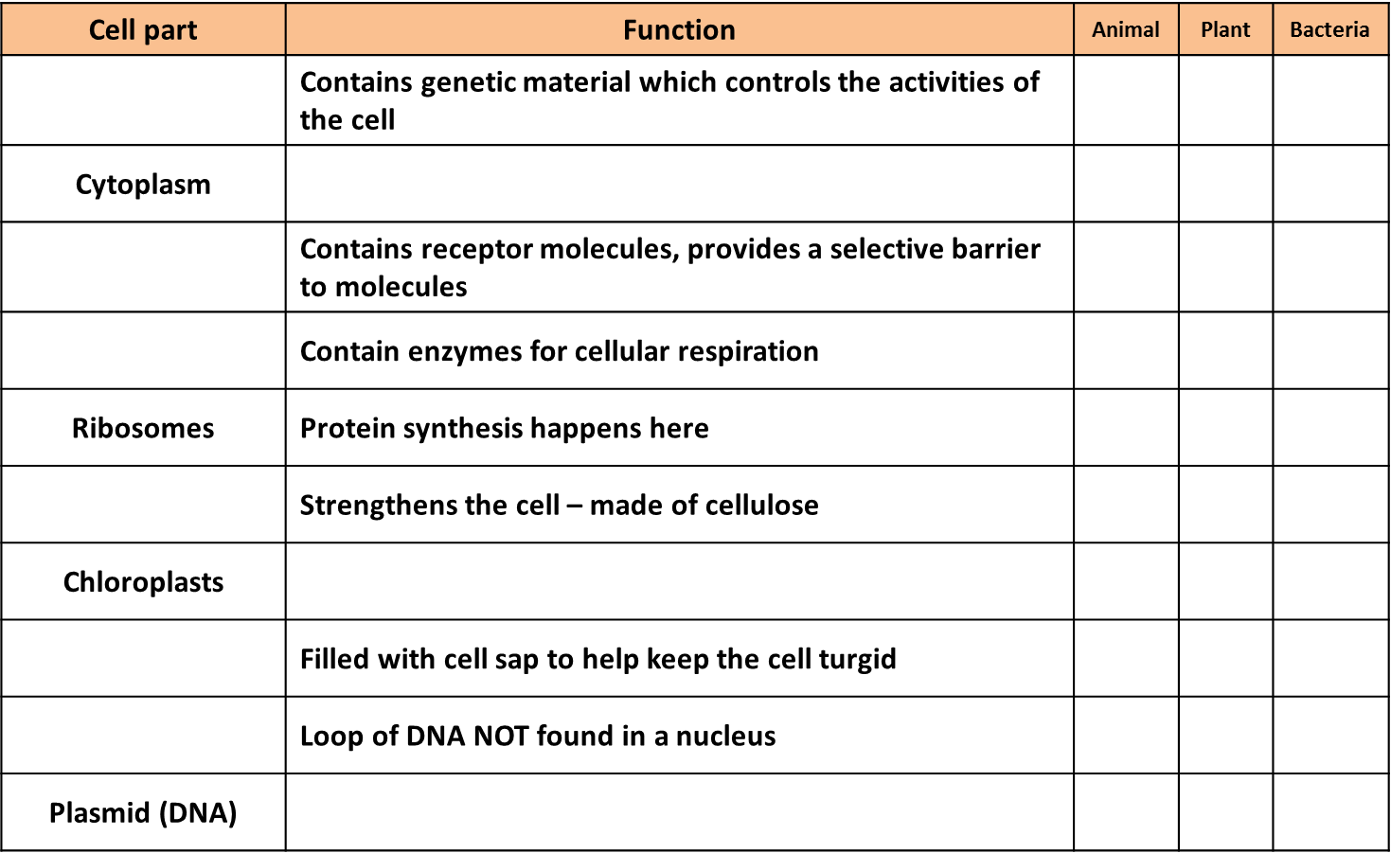

B. Cell structures – Part 2
- Name animal cells A, B and C and describe their structure and function.
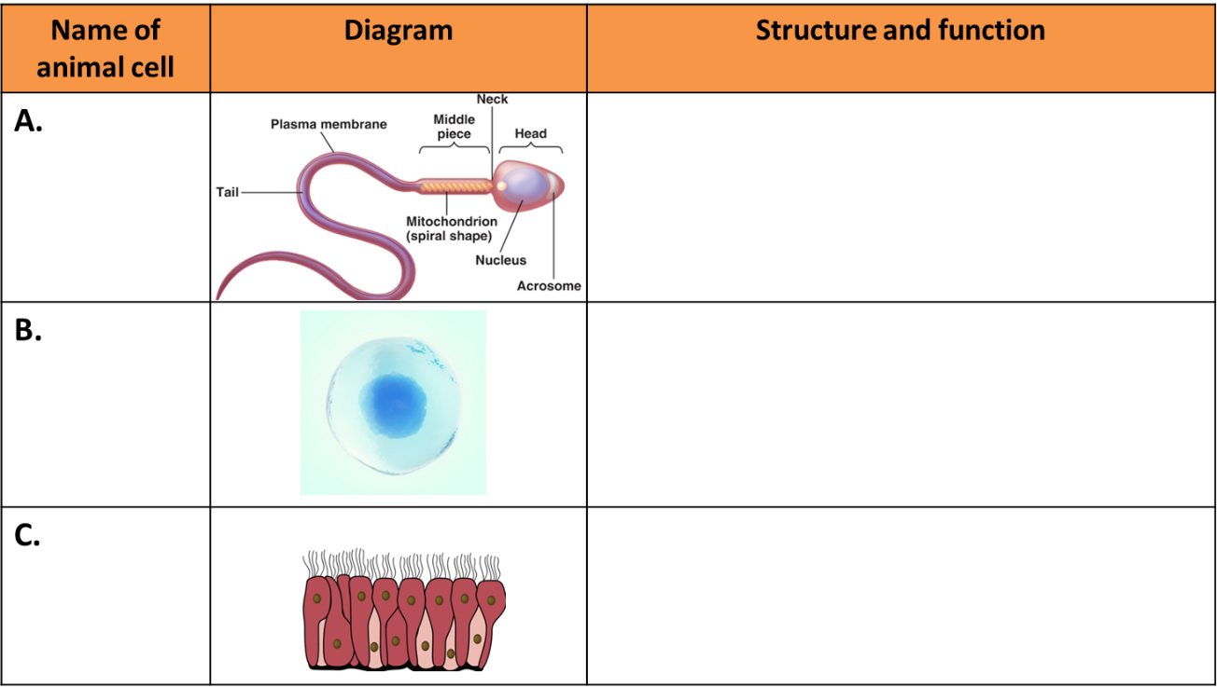
C. Cell structures – Part 3
- Define the term ‘resolution’.
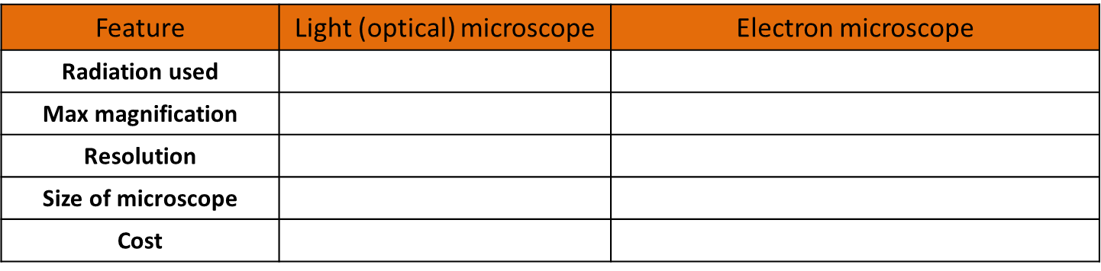
- Copy and complete the table below.
- What are the advantages of the electron microscope?
- Name the smallest cell structures that can be seen by the light microscope?
- What are the smallest cell structures that can be seen by the electron microscope?
- Write down the magnification equation.
- Rearrange the equation to change the subject for the two other factors.
- A magnified cell structure has a diameter of 375𝛍m. The actual diameter of the structure is 2.5𝛍m. Calculate how many times the structure has been magnified.
- The actual length of a cell structure is 3𝛍m. It is magnified 1,500 times. Calculate the length of the magnified cell structure in mm.
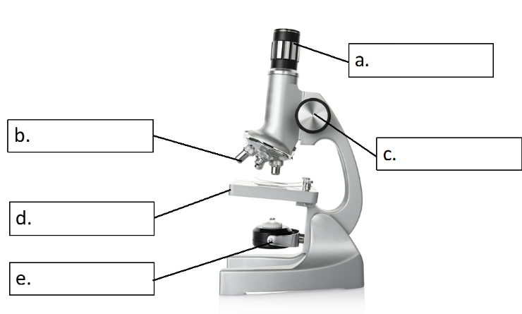
- Name the parts of the light microscope in the diagram below.

- How would you make an onion cell slide?
- How would you use the light microscope to view onion cells?
D. Enzymes and food tests
- What is digestion?
- What is an enzyme?
- Complete the table below:
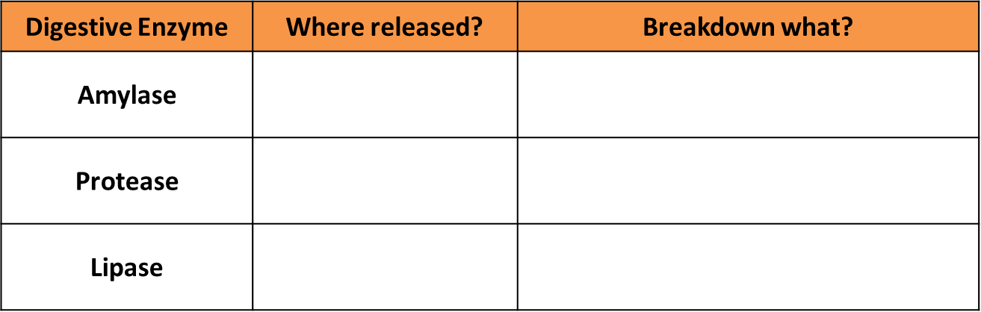

- What biological molecule are enzymes made of?
- What is the active site of an enzyme?
- What is a substrate?
- What are the products of digestion used for in the body?
- What does denatured mean?
- How does increasing the temperature affect enzyme activity?
- How does pH affect enzyme activity?
- What is the role of bile in digestion?
- Enzymes are also required to catalyse the synthesis of larger molecules. Complete the table to show what complex molecules are being made:
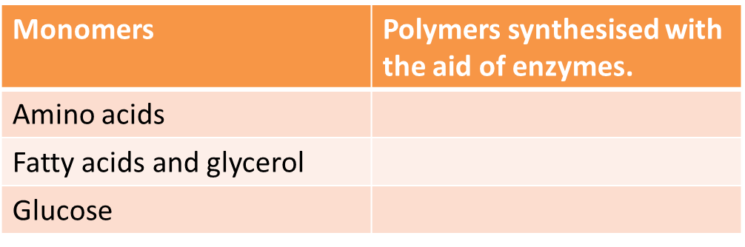
Biology Only
- What reagent is used to identify the presence of starch?
- Which reagent is used to identify the presence of a reducing sugar?
- Which test is used to identify if protein is present?
- Which flammable reagent is used in the emulsion test for lipids?
- List the equipment needed to find out how much energy is in 1g of peanuts.
E. Transport in cells
- Define ‘diffusion’.
- State three places where diffusion occurs in the body.
- What is a concentration gradient?
- What three factors affect the concentration gradient?
- Define ‘osmosis’.
- What is a ‘partially permeable membrane’?
- What happens to an animal cell in a hypertonic solution?
- What happens to an animal cell in a hypotonic solution?
- Define ‘active transport’.
- Why does active transport need to occur in root hair cells?
- Why is percentage change in mass calculated for osmosis results?

